Project 12

Frederick Kelemen

2715308

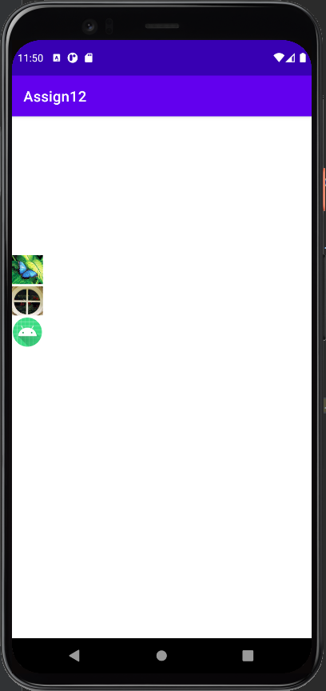Project 3 displays three images as buttons, the buttons show the entire blown up image at the bottom of the screen when pressed, the buttons are setup in a gridview, on clicking one of the grid squares, the imageview resource is set to the same as that of the image in the grid.

